Year 5 spelling lists for Spring 2
Tests take place on a Friday, children have a week to learn their spellings- the date is the date they will be tested.
3rd March | 10th March | 17th March | 24th March
Words where ‘ei’ can make an _ee_ sound | Words where ‘ough’ makes an /or/ sound | Words containing 'ough' | Words that are adverbs of possibility and frequency
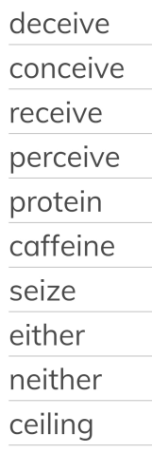 | 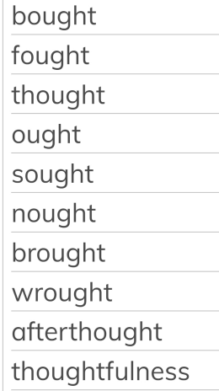 | 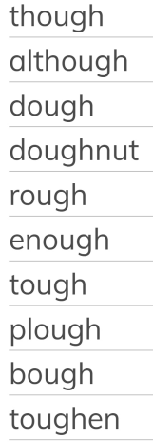 | 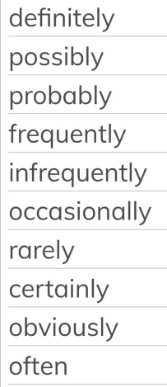
31st March |  | 28th April (Summer 1)
Challenge words |  | Words that are homophones or near homophones
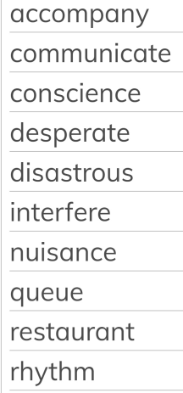 |  | 