Year 5 spelling lists for Spring 1
Tests take place on a Friday, children have a week to learn their spellings- the date is the date they will be tested.
13th January | 20th January | 27th January | 3rd February
Words that are adverbs of time | Words with suffixes where the base word ends in ‘-fer’ | Words with silent first letters | Silent letters
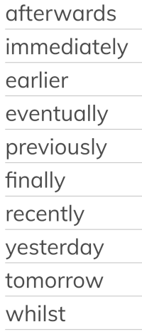 | 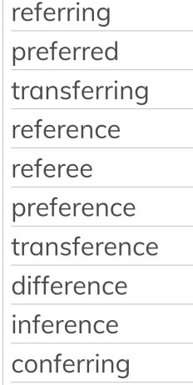 | 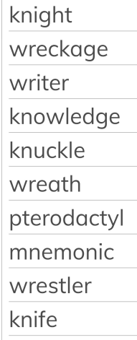 | 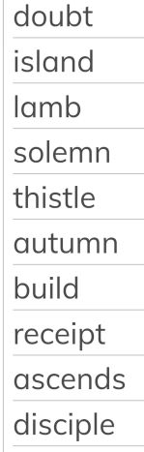
10th February |  | 17th February | 3rd March (Spring 2)
Challenge words |  | Words with 'ie' after 'c' | Words where ‘ei’ can make an _ee_ sound
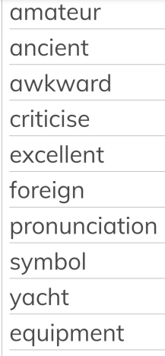 |  | 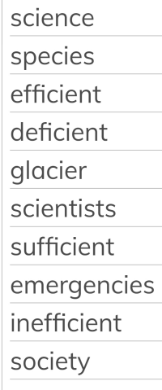 | 